***Type: xxx***

**Deep Learning Based Melanoma Detection Using ResNet50**

**By Analyzing Dermoscopic Images**

# Md. Fahim Uddin1, Nafisa Tafshir2, Mohammad Monirujjaman Khan1, *

1Department of Electrical and Computer Engineering,   
North South University, Bashundhara, Dhaka-1229, Bangladesh.  
*Corresponding Author: Mohammad Monirujjaman Khan. Email: monirujjaman.khan@northsouth.edu   
Received: XX Month 202X; Accepted: XX Month 202X

**Abstract:** Melanoma is a serious form of skin cancer that begins in cells known as melanocytes. It is more dangerous because of its ability to spread to other organs more rapidly if it is not treated at an early stage. Basically, Melanoma presents in many different shapes, sizes, and colors. That’s why it’s tricky to provide a comprehensive set of warning signs. It is usually curable when detected and treated early. Once melanoma has spread deeper into the skin or other parts of the body, it becomes more difficult to treat and can be deadly. While curable with early detection, only highly-trained specialists are capable of accurately recognizing the disease. So, we propose a system that combines recent developments in deep learning with established machine learning approaches, creating ensembles of methods that are capable of segmenting skin lesions, as well as analyzing the detected area and surrounding tissue for melanoma detection. In this paper, we propose a method for classifying melanoma images into benign and malignant images using Convolutional Neural Networks (CNNs). Classifying melanoma from dermoscopic images is now a current trend in AI-based skin cancer detection methods but the prerequisite is highly computation tools that take much time, effort, and cost as well. In these cases, researchers train a huge number of images with 'Deep Learning' algorithms, basically with pretty deep neural architectures containing a huge number of parameters to train with, though they got their expected outcomes. In our research, we emphasized building models with less complexity and comparatively better accuracy, so that melanoma can be identified with ease. Using ResNet50 model architecture our model achieves accuracy over 95% (Expected), which is a decent accuracy to predict melanoma. Moreover, which is better than the previous state-of-the-art approaches. Our main goal was to achieve as much accuracy with partially fewer deep networks so that the system can predict Melanoma from input dermoscopic images as correctly as possible within devices with less computational power.

**Keywords:** Melanoma, Machine Learning, Deep Learning, CNN, ResNet50

1. **Introduction**

Skin cancer is known as one of the riskiest types of cancer. Several kinds of skin cancer, such as melanoma, basal and squamous cell carcinoma, etc., are available. The most unpredictable cancer is melanoma.[18]

According to the latest WHO data published in 2018 Skin Cancers Deaths in Bangladesh reached 301 or 0.04% of total deaths. The age-adjusted Death Rate is 0.26 per 100,000 population ranks Bangladesh #183 in the world.[19] If we again look at the statistics from WHO, there are 324,635 new cases all around the globe, from which a total of 57,043 are death cases. It showed 18 people out of 100, can’t survive who had been diagnosed with Melanoma whether we stated it as curable [20]. So, there is no doubt it’s alarming and a matter of concern to dermatologists all across the globe.

Each year there are approximately 5.4 million new cases of skin cancer recorded in the USA alone. The global statistics are equally alarming. Recent reports show that the incidence of melanoma has risen considerably over the past 30 years, and more than 96,000 new cases are estimated to be diagnosed in the United States in 2019 {according to the recently published Cancer Facts & Figures 2019 report from the American Cancer Society}. The mortality rate of this disease is expected to rise in the next decade. The survival rate is less than 14% if diagnosed in later stages. However, if skin cancer is detected at early stages, the survival rate is nearly 97%. This demands the early detection of skin cancer. This project will address the issue of early diagnosis with improved accuracy.[1]

Skin cancer is very common in Europe, Australia, and the USA [14] and is almost always curable if recognized and treated early. The major risk factors related are skin color, sun exposure, climate, advanced age, genetic and familial history. The best way to detect melanoma is to recognize a new spot in the skin or a spot that is changing in size, shape, and color. Early detection of skin cancer can avoid death [15]

In today’s age, computer-aided diagnosis systems through using machine learning and deep learning have become a requirement for the early detection and diagnosis of many fatal diseases. Our system also represents a computer-aided diagnosis system,[21] where the system classifies and detects if an image of the damaged skin is melanoma cancer or not. It has been done with the help of deep layered convolutional network algorithms. The deep layers of CNN train the data set and extract the features more easily and accurately. Image processing has been done also to remove noise from image data and to prepare it more convenient and suitable to train in the model.

There has been a lot of work published in the domain of skin cancer classification using deep learning and computer vision techniques. These works use a lot of different approaches including classification only, segmentation and detection, image processing using different types of filters, etc.

**(Esteva et al., 2017)** separately used AdaBoost to [22] classify skin lesions. **(Xu et al., 2014)** used different sets of features including the type of lesion, texture, color, etc., and neural networks for the making of a robust diagnosis system.[23] The examples till now only showed algorithms using traditional machine learning techniques, but lately, deep learning has proved to be more accurate. The reason is that it automates the feature extraction process completely. It is up to the algorithms to find the better features and train the model accordingly. In **(Lopez et al., 2017)** made a breakthrough on skin cancer[4] classification by a pre-trained GoogleNet Inception v3 CNN model to classify 129,450 clinical skin cancer images including 3,374 dermatoscopic images. **(Dorj et** **al., 2018)** developed a convolutional neural network with over 50 layers on the ISBI 2016 challenge dataset for the classification [24] of malignant melanoma. In 2018, **(Brinker et al., 2018)** utilized a deep convolutional neural network to[25] classify a binary class problem of dermoscopy images. **(Rezvantalab et al., 2018)** developed an algorithm using Support [10] Vector Machines combined with a deep convolutional neural network approach for the classification of 4 diagnostic categories of clinical skin cancer images. **(Codella et al., 2017)** used a deep convolutional neural network to classify the clinical images of 12 skin diseases.[8]

An automated diagnosis system for melanoma detection using dermoscopy images is created in this paper. For melanoma identification, we used some features related to shape, size, and color attributes with an overall accuracy of more than 95% (expected). We are using ResNet50 architecture to train our model.

The remaining sections of this paper highlight the methods and materials used to design and

construct the system; the progressing results we have achieved so far conclude in Section 3.We even showed the accuracy and the purpose of some previous works related to Melanoma Detection in Table 3.

1. **Method and Methodology**

We are using the concept of ResNet50 for classification. With ResNet50, instead of starting the learning process from scratch, the model starts from patterns that have been learned when solving a different problem. This way, the model leverages previous learnings and avoids starting from scratch. In image classification, ResNet50 is usually expressed through the use of pre-trained models. A pre-trained model is a model that was trained on a large benchmark dataset to solve a problem similar to the one that we want to solve.

Moreover, we are using a Google Colab to build the model.

* 1. ***Dataset***

Every year International Symposium on Biomedical Imaging (ISBI) creates challenges in different aspects of biomedical fields. One of the challenges is Skin Cancer detection. The dataset we used for skin cancer detection was available on the ISIC [16] website, from the competition held in 2016. We took 5000 images of Benign and 5000 images of Malignant. To train our model we used 3500 images of each benign and malignant class and 1500 images for our testing.

This website contains different sizes of images, where we need to resize them. We resize our image to (224, 224, 3). So, our input image shape is (224, 224,3). Here is some glimpse of images we took for our tasks:

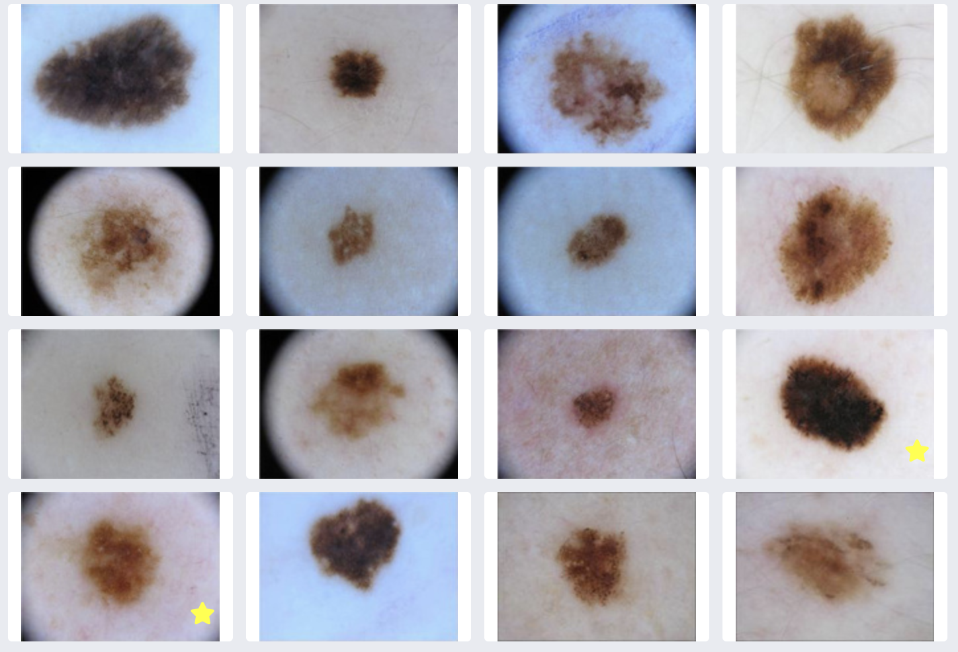

**Figure 1:** Random input images from ISIC dataset [16]

Dataset Link: [ISIC Archive](https://www.isic-archive.com/#!/topWithHeader/onlyHeaderTop/gallery?filter=%5B%22meta.clinical.benign_malignant%7Cbenign%22%2C%22meta.clinical.benign_malignant%7Cmalignant%22%5D)

* 1. ***Convolutional Neural Networks (CNN)***

CNN’s are a kind of neural network that has proven to be very powerful in image recognition and classification. CNN’s can identify faces, pedestrians, traffic signs, and other objects better than humans and therefore are used in real-time applications like robots and self-driving cars. CNN’s are a supervised learning method and are trained using labeled data given with the respective classes. CNN’s learn the relationship between the input objects and the class labels and comprise two components: the hidden layers in which the features are extracted and, at the end of the processing, the fully connected layers used for the actual classification task. The hidden layers of CNN have a specific architecture consisting of convolutional layers, pooling layers, and activation functions for switching the neurons either on or off. In a typical neural network, each layer is formed by a set of neurons, and one neuron of a layer is connected to each neuron of the preceding layer while the architecture of hidden layers in CNN is slightly different. The neurons in a layer are not connected to all neurons of the preceding layer; instead, they are connected to only a small number of neurons from the previous layer. This restriction to local connections and additional pooling layers summarizing local neuron outputs into one value results in translation-invariant features. This results in a more straightforward training procedure due to fewer parameters and lower model complexity. The diagram as follows:

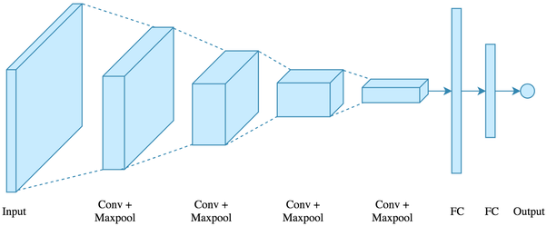

**Figure 2:** Layers of CNN [2]

* 1. ***ResNet50***

Deep neural networks lead to a number of image classification breakthroughs. Many other tasks of visual recognition have benefited greatly from very profound models. Over the years, therefore, there is a tendency to deepen and to solve more difficult tasks as well as to improve accuracy. However, as we go deeper, neural network training becomes hard and accuracy begins to saturate and also degrade, such problems are being solved by residual learning.

ResNet50 architecture is our primary model to train our dataset upon, that is our teacher model. ResNet indicates Residual Network that defines ‘residual learning’ as key terminology introduced by this network. ResNet50 is a deep network of residuals with 50 layers and this ResNet50 is very popular in classification tasks. The principal innovation of ResNet is the skip connection. As you most likely are aware, without changes, deep networks regularly experience the vanishing gradient problem, ie: as the model backpropagation, the inclination gets more modest and more modest. Small gradients can make learning unmanageable. The skip connection in the outline beneath is named "identity." It permits the network to gain proficiency with the identity function, which permits it to go the input through the square without going through the other weight layers. It can therefore stack extra layers and establish a deeper network by compensating for the disappearance gradient, allowing our network to overcome complexities in training.

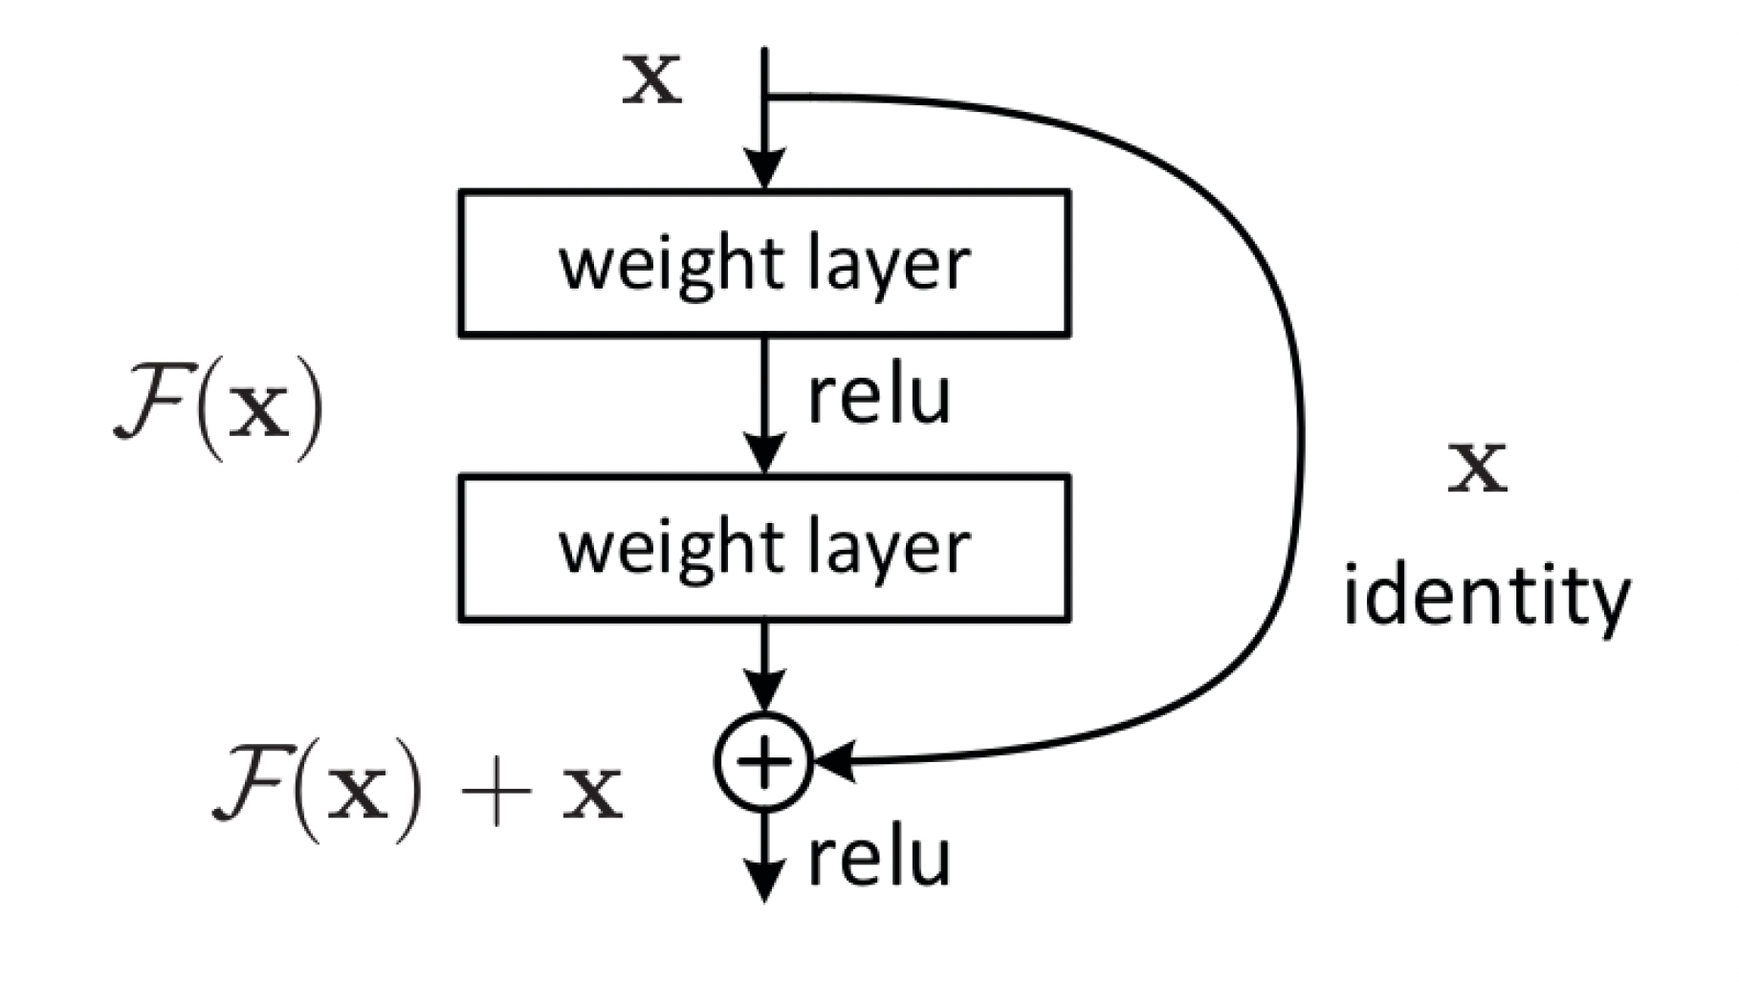

**Figure 3:** Residual Learning [26]

In our model, we use the pre-trained version of ResNet50 which has around 23,542,786 trainable parameters. The pre-trained model took weights from the ImageNet dataset. The input images size was all resized to (224, 224) to be compatible with this model. The learning rate was set to 0.0001 and Adam was used for the optimizer.

***2.4 System Flowchart***

The system will work as follows to predict melanoma.

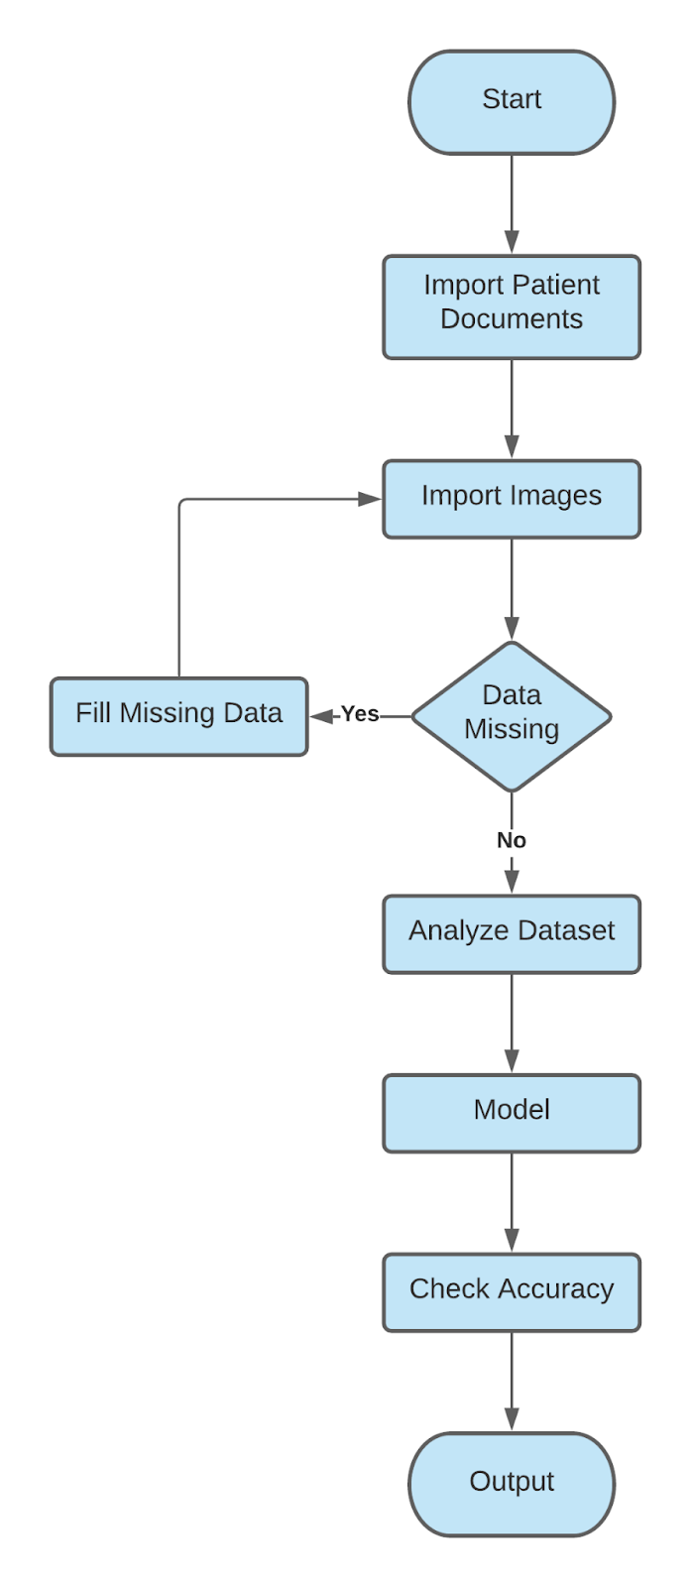

**Figure 4:** System Flowchart

According to the following flowchart, the system will import patient data at first. Then the system will analyze the data & input the data in the Build Model. Then the model will check the accuracy.

***2.5 Proposed Model***

This is the proposed model of the whole system using ResNet50

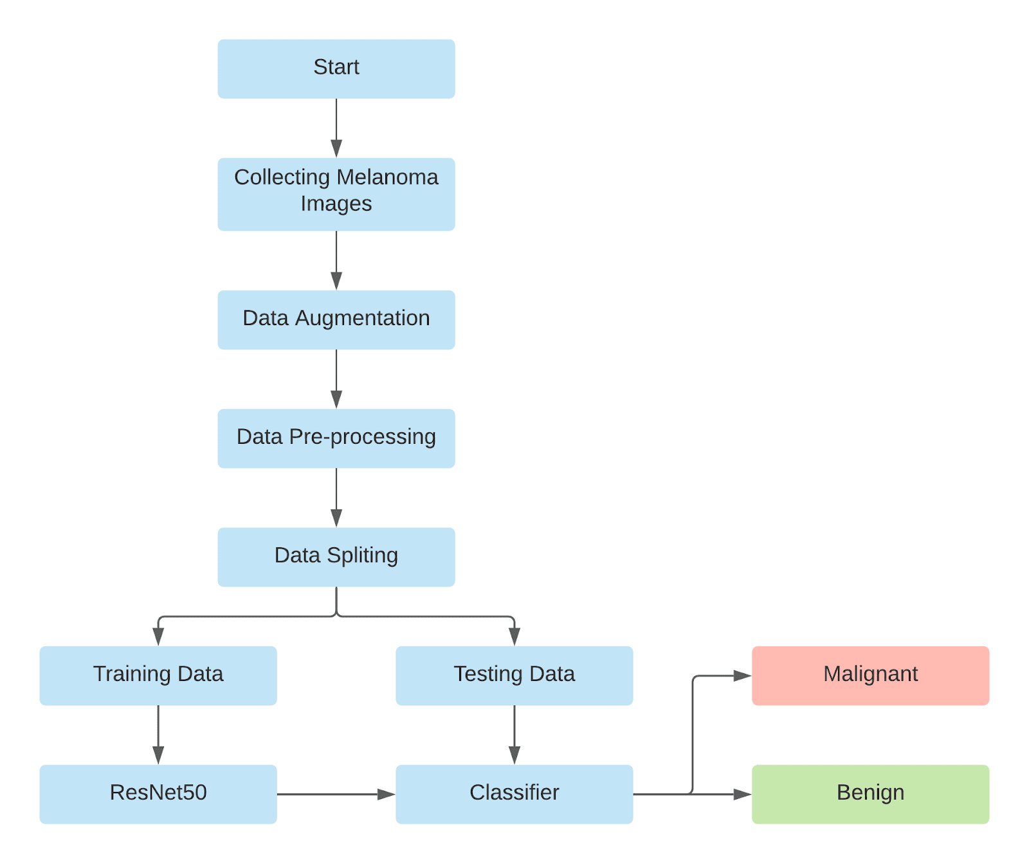

**Figure 5:** Proposed Model of using ResNet50

During the training of our model, we have to complete visualization of the dataset as the images of the dataset will be larger. Then we will split the data into train & test. The percentage of train & test will be as follows: Train - 70% & Test - 30%. There will be a classifier that will decide the output of the model.

***2.6 Proposed Solution***

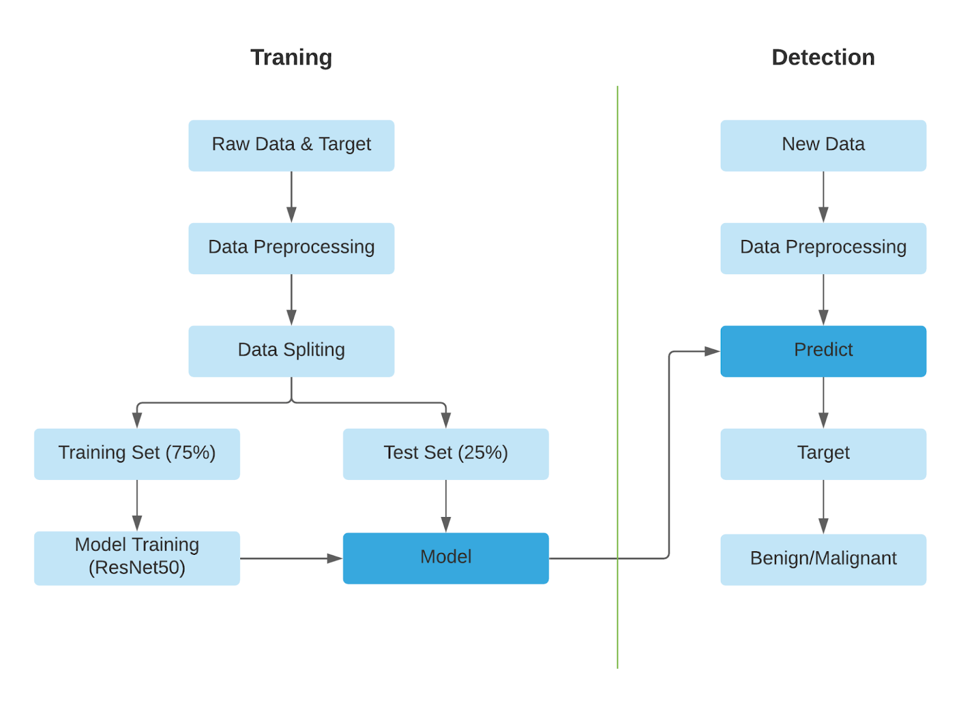

**Figure 6:** Proposed Solution

After preprocessing data, we will split the data into two portions. 70% will be used to train the model & 30% data will be used to test the model. After training the model the new data will be predicted in the trained model. Afterward, the model gives the predicted result if the tumor is benign or malignant.

**Costing:** As the software & tools we are going to need in this project are available on the website. Moreover, the dataset for this project is also available on the web. Hence, we don’t need any financial support to complete this research-based project. But, in the future when we will build & launch our software then we may need financial support.

1. **Results and Analysis**

So far in this semester, we have successfully completed our Data Visualization, Model Building.

After downloading the dataset we divide the images as follows & uploaded our dataset images in Google Drive for easier access in Google Colab. We took 3500 for training & 1500 for validation for both benign & malignant. So, overall the percentage of the training dataset & validation dataset is 70% & 30%.

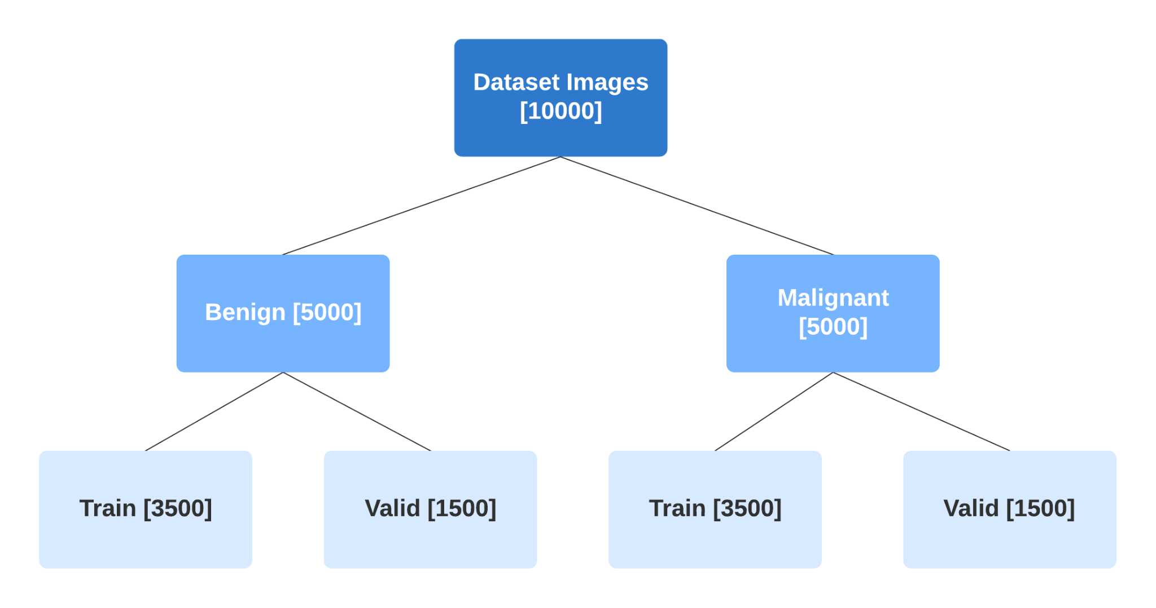

**Figure 7:**Data splitting

The images of melanoma we collected from ISIC are very big in size. Due to the lack of a powerful GPU, we have resized our Dataset image size. We resized our dataset images 224 px * 224 px. Here is the result of our resized images.

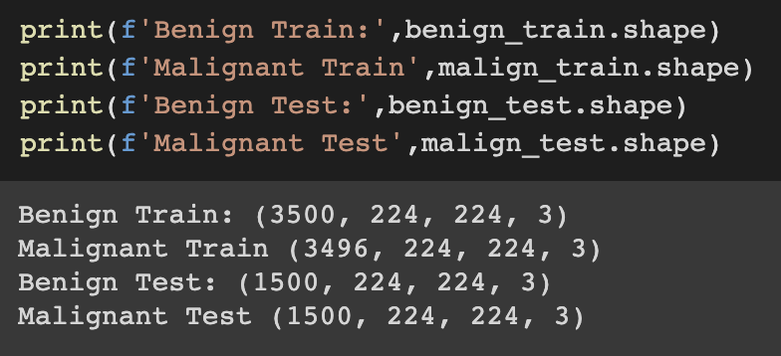

**Figure 8:** Image resize

After completing the visualization process here is the final result of our dataset. We can see that all our images have been labeled. Images are resized in 224 px * 224 px .

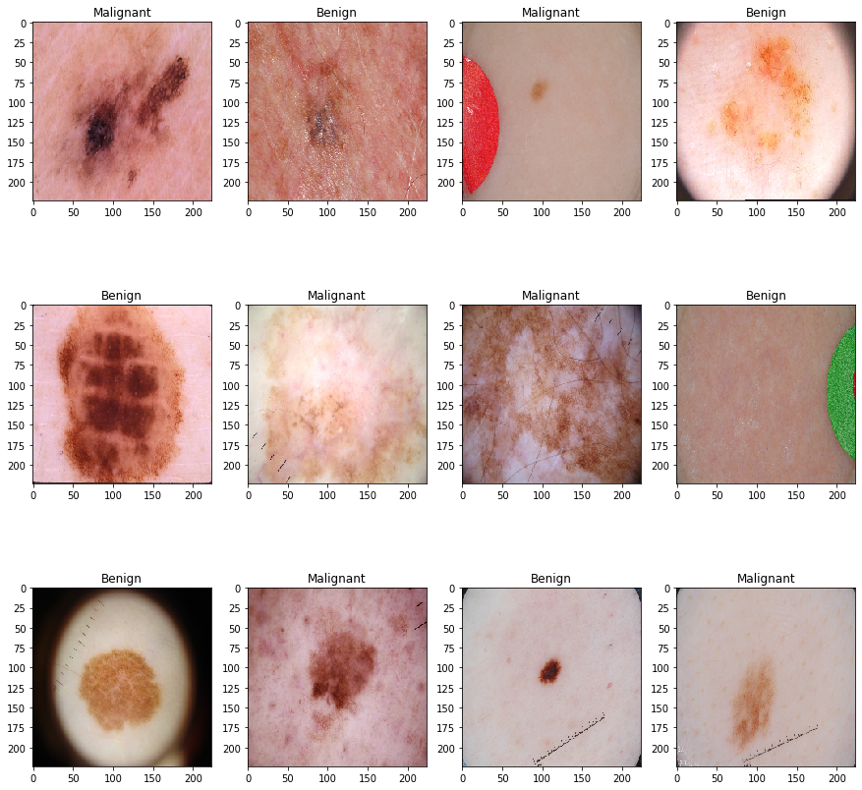

**Figure 9:** Result after visualization

Before training the model we have labeled our dataset. We labeled class 0 for our benign images & class 1 for our malignant images. So that, the model can differentiate benign and malignant.

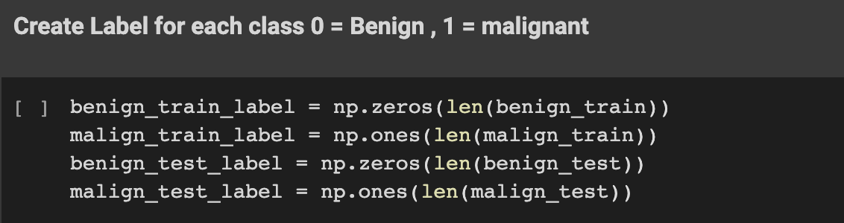

**Figure 10:** Image labeling

Then we split the dataset into train & valid as follow

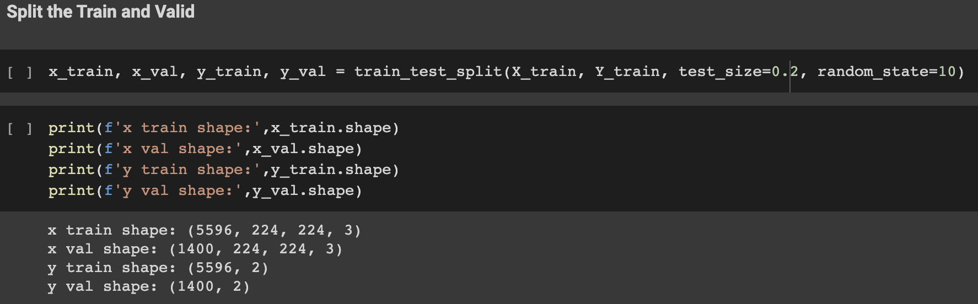

**Figure 11:** Image splitting

To improve our accuracy, we have used a Keras Data Generator to randomly shuffle our images. We have used zoom, rotate, flip parameters to generate data.

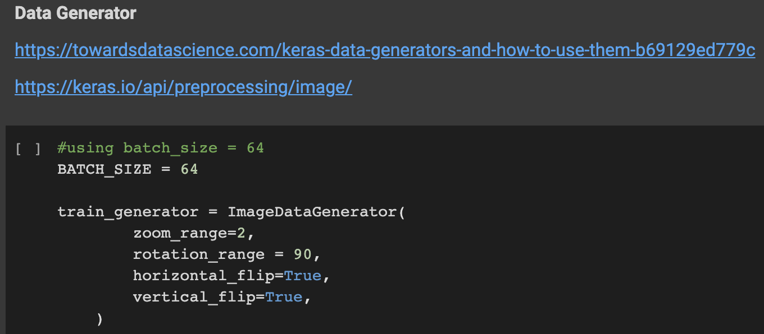

**Figure 12:** Keras data generator

Then we build our ResNet50 Model. while building the model using ResNet50 we set the learning rate to 0.001.

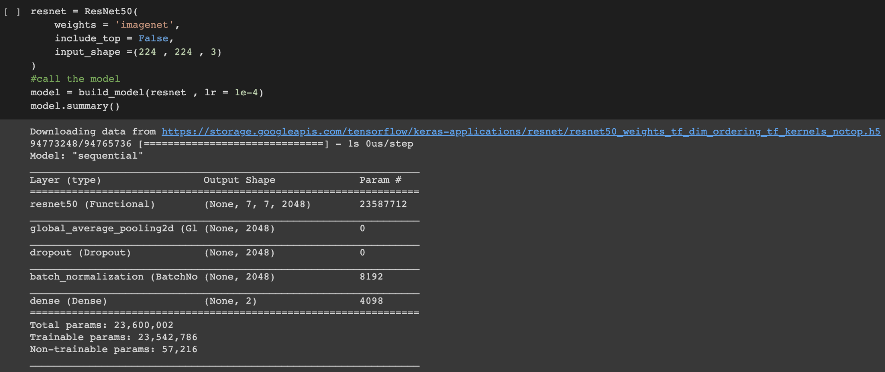

**Figure 13:** ResNet50 model

In this section, we present our findings. We plotted the loss vs epochs, accuracy vs epochs, confusion matrix for the classifier, and ROC-AUC curve for the classifier.

We evaluated the performance of the proposed model based on different metrics: accuracy, recall, sensitivity, specificity, and precision. &e metrics are evaluated by various parameters in the confusion matrix, such as true positive (TP), true negative (TN), false positive (FP), and false-negative (FN).

$$Recall =\frac{TP}{(TP+FN)}$$

$$Precision =\frac{TP}{(TP+FP)}$$

The details of the experiment demonstrating the effect of training dataset size are shown in Table 1

|  |  |  |  |
| --- | --- | --- | --- |
| **Train Size** | **Precision** | **Recall** | **F1 Score** |
|  |  |  |  |
|  |  |  |  |

**Table 1:** Effect of batch size on the result

Next, we present our findings and show the validation of our trained models. In this paper, two types of major skin cancer categories are used. The evaluation and results of trained models are calculated by common classification metrics. The ROC curve is calculated by plotting the sensitivity against 1 specificity and can be used to evaluate the classifier. The further the ROC curve deviates from the diagonal, the better the classifier.

|  |  |  |  |  |  |
| --- | --- | --- | --- | --- | --- |
| **Batch Size** | **Accuracy** | **Precision** | **Recall** | **F1 Score** | **ROC-AUC** |
|  |  |  |  |  |  |
|  |  |  |  |  |  |
|  |  |  |  |  |  |

**Table 2:** Effect of learning rate on the result

|  |  |  |  |
| --- | --- | --- | --- |
| **Year** | **Author** | **Purpose** | **Accuracy** |
| 2016 [7] | 1. V. Pomponiu | Deep neural networks for skin mole lesion classification. | 93.64 |
| 2017 [8] | 1. N. C. Codella | Deep learning ensembles for melanoma recognition in dermoscopy images | 93.1 |
| 2018 [9] | 1. H. A. Haenssle | diagnostic performance of a deep learning convolutional neural network for dermoscopic melanoma recognition in comparison to 58 dermatologists. | -------- |
| 2017 [6] | 1. L. Bi | Automatic skin lesion analysis using large-scale dermoscopy images and deep residual networks | -------- |
| 2018 [17] | 1. S. S. Han | Classification of the clinical images for benign and malignant cutaneous tumors using a deep learning algorithm | -------- |
| 2016 [5] | 1. J. Kawahara and G. Hamarneh | Multi-resolution-tract cnn with hybrid pretrained and skin-lesion trained layers. | 79.5 |
| 2017 [4] | 1. A. R. Lopez | Skin lesion classification from dermoscopic images using deep learning techniques | 81.33 |

**Table 3:** Comparison with previous work

1. **Conclusion**

This Melanoma cancer is a cancer that is difficult to detect in an ordinary way. Besides being a person with melanoma cancer who does not feel pain, the form of melanoma cancer is also similar to ordinary moles. In the case of melanoma cancer, the damage to DNA is caused by overexposure to ultraviolet rays (UV), and the affected cells are the melanocytes that produce melanin (pigmentation of the skin).In conclusion, this study will investigate the ability of deep convolutional neural networks in the classification of benign vs malignant skin cancer We Will try to show that with use of very deep convolutional neural networks using transfer learning and fine-tuning them on dermoscopy images, better diagnostic accuracy can be achieved compared to expert physicians and clinicians if a cost-effective system can be built, it can easily be reachable to general people and melanoma screening can be easier. And yes, saving lives is our ultimate goal. To build a cost-effective model, we presented the knowledge distillation method. A way of transferring knowledge from one network to another, with experimental results over several images of Melanoma datasets the main goal was to save lives from diseases like Melanoma with the help of new technology.

**Acknowledgment:** Authors would like to thank the Department of Electrical and Computer Engineering of North South University

**Conflicts of Interest:** “The authors declare that they have no conflicts of interest to report regarding the present study.”

**References**

1. <https://www.sciencedirect.com/science/article/pii/S2352914819302047>
2. <https://www.quora.com/What-is-a-convolutional-neural-network>
3. <https://sci-hub.se/https://ieeexplore.ieee.org/abstract/document/9034624>
4. A. R. Lopez, X. Giro-i Nieto, J. Burdick, and O. Marques. Skin lesion classification from dermoscopic images using deep learning techniques. In 2017 13th IASTED international conference on biomedical engineering (BioMed), pages 49–54. IEEE, 2017.
5. J. Kawahara and G. Hamarneh. Multi-resolution-tract cnn with hybrid pretrained and skin-lesion trained layers. International workshop on machine learning in medical imaging, pages 164–171.Springer, 2016.
6. L. Bi, J. Kim, E. Ahn, and D. Feng. Automatic skin lesion analysis using large-scale dermoscopy images and deep residual networks. arXiv preprint arXiv:1703.04197, 2017.
7. V. Pomponiu, H. Nejati, and N.-M. Cheung. Deepmole: Deep neural networks for skin mole lesion classification. In 2016 IEEE International Conference on Image Processing (ICIP), pages 2623–2627. IEEE, 2016.
8. N. C. Codella, Q.-B. Nguyen, S. Pankanti, D. A. Gutman, B. Helba, A. C. Halpern, and J. R. Smith. Deep learning ensembles for melanoma recognition in dermoscopy images. IBM Journal of Research and Development, 61(4/5):5–1, 2017.
9. H. A. Haenssle, C. Fink, R. Schneiderbauer, F. Toberer, T. Buhl, A. Blum, A. Kalloo, A. B. H.Hassen, L. Thomas, A. Enk, et al. Man against machine: diagnostic performance of a deep learning convolutional neural network for dermoscopic melanoma recognition in comparison to 58 dermatologists. Annals of Oncology, 29(8):1836–1842, 2018.
10. A. Rezvantalab, H. Safigholi, and S. Karimijeshni. Dermatologist level dermoscopy skin cancer classification using different deep learning convolutional neural networks algorithms. arXiv preprint arXiv:1810.10348, 2018.
11. <https://www.researchgate.net/publication/340880583_Analyzing_Lung_Disease_Using_Highly_Effective_Deep_Learning_Techniques>
12. ISIC Challenge. Available: https://challenge.isic-archive.com/.
13. S. Ogden and N. R. Telfer, “Skin cancer,” Medicine (Baltimore) 37(6), 305–308 (2009).
14. S. Ogden and N. R. Telfer, “Skin cancer,” Medicine (Baltimore) 37(6), 305–308 (2009).
15. A. O. Berg, D. Best; US Preventive Services Task Force, “Screening for Skin Cancer: recommendations and rationale,” Am. J. Prev. Med. 20(3 Suppl), 44–46 (2001).
16. <https://tinyurl.com/isicmelanomadataset>
17. S. S. Han, M. S. Kim, W. Lim, G. H. Park, I. Park, and S. E. Chang. Classification of the clinical images for benign and malignant cutaneous tumors using a deep learning algorithm. Journal of Investigative Dermatology, 138(7):1529–1538, 2018.
18. <https://www.researchgate.net/publication/336232050_Automatic_Detection_and_Analysis_of_Melanoma_Skin_Cancer_using_Dermoscopy_Images>
19. <https://www.worldlifeexpectancy.com/bangladesh-skin-cancers>
20. H Sung, J Ferlay, RL Siegel, M Laversanne, I Soerjomataram, A Jemal, F Bray, “Global Cancer Statistics 2020: GLOBOCAN Estimates of Incidence and Mortality Worldwide for 36 Cancers in 185 Countries”, CA Cancer J Clin., vol.;71(3),pp.209-249, May 2021.
21. <https://ieeexplore.ieee.org/document/9263118>
22. A. Esteva, B. Kuprel, R. A. Novoa, J. Ko, S. M. Swetter, H. M. Blau, and S. Thrun. Dermatologist Level classification of skin cancer with deep neural networks. nature, 542(7639):115–118, 2017.
23. Xu, J. S. Ren, C. Liu, and J. Jia. Deep convolutional neural network for image deconvolution. In Advances in neural information processing systems, pages 1790–1798, 2014.
24. U.-O. Dorj, K.-K. Lee, J.-Y. Choi, and M. Lee. The skin cancer classification using deep convolutional neural network. Multimedia Tools and Applications, 77(8):9909–9924, 2018.
25. T. J. Brinker, A. Hekler, J. S. Utikal, N. Grabe, D. Schadendorf, J. Klode, C. Berking, T. Steeb, A. H.Enk, and C. von Kalle. Skin cancer classification using convolutional neural networks: systematic review. Journal of medical Internet research, 20(10):e11936, 2018.
26. K. He, X. Zhang, S. Ren, J. Sun, "Deep Residual Learning for Image Recognition", arXiv preprint, arXiv:1512.03385v1, 2015.